DCCI Business Institute (DBI) Visits LEADS Corporation Limited

LEADS arranged an industrial visit for DCCI Business Institute’s 3rd and 4th year students at the office premises on January 28, 2019 giving them a unique first-hand experience of how an IT company operates.

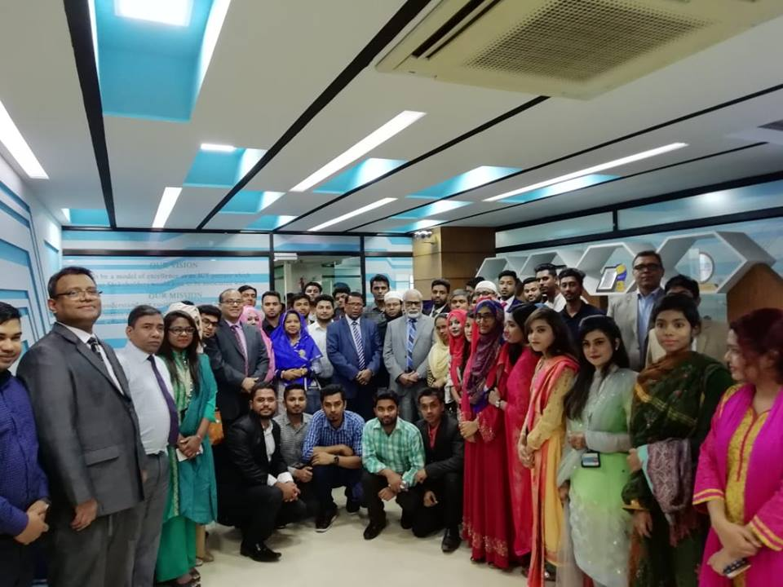

Leads Chairman along with Leads Team members and delegates of DBI

During the visit the students got a sneak peek into what LEADS Corporation Limited is all about. Mr. Rana Shohel, Chief Operating Officer, LEADS started the program with a presentation on LEADS company profile. Mr. SM Saifur Rahman Head of Product Marketing presented the LEADS products and services. During the interactive session students were briefed about the history, operations, client base and the business procedures of the company.
The departmental heads provided the students with valuable insights into the corporate world as well as a real-world perspective on different functions in the organization such as Software Services, Marketing, HR, Finance, Supply Chain, Digital Innovation Customer Support and Service Divisionetc. Mr. Sadat Anwar, Head of Human Resources Department gave the studentsidea about LEADS’ recruitment and selection policy as well as the work environment at the, company.
LEADS Chairman Mr. Shaikh Abdul Aziz along with Mr. Shaikh Wahid, MD & CEO,Mr. Masud Parvez, Chief Financial Officer, Mr. Papias Hawlader, Chief Information Officer, Mr. B.E.M. Manjur-e-Khuda, General manager, and Mr. Sk. Abdullah Al Mamun, Head of Government Systems was present in the program.
A total of 35 students along with 4 faculty members and the principal of DBI College Ms. Khodeza Begum participated in the program. The program was concluded through a vote of thanks by Mr. Shaikh Wahid.

