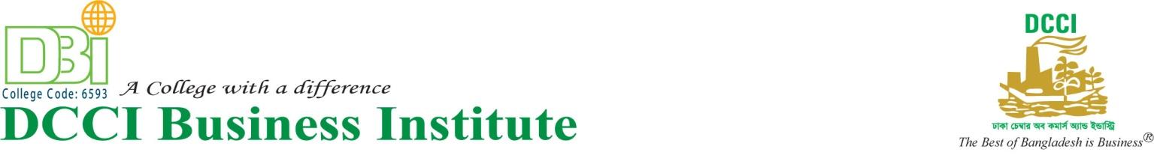
“International Clean Technology Fair 2019”
A technology fair was conducted under Metabuild Project of DCCI from 26th June to 27th June 2019. It was held on IDEB Bhaban ,Kakrail, Dhaka. The fair was inaugurated by the honorable Senior Vice President Mr. Waqar Ahmad Chowdhury and the Vice President Mr. Imran Ahmed. Honorable Principal of DBI College, Mrs. Khodeza Begum was also present in the fair. Mr. Fahad Bin Roshed, Faculty of DBI College along with some Student visited the fair. The fair was based on different machineries that can be used in industries.
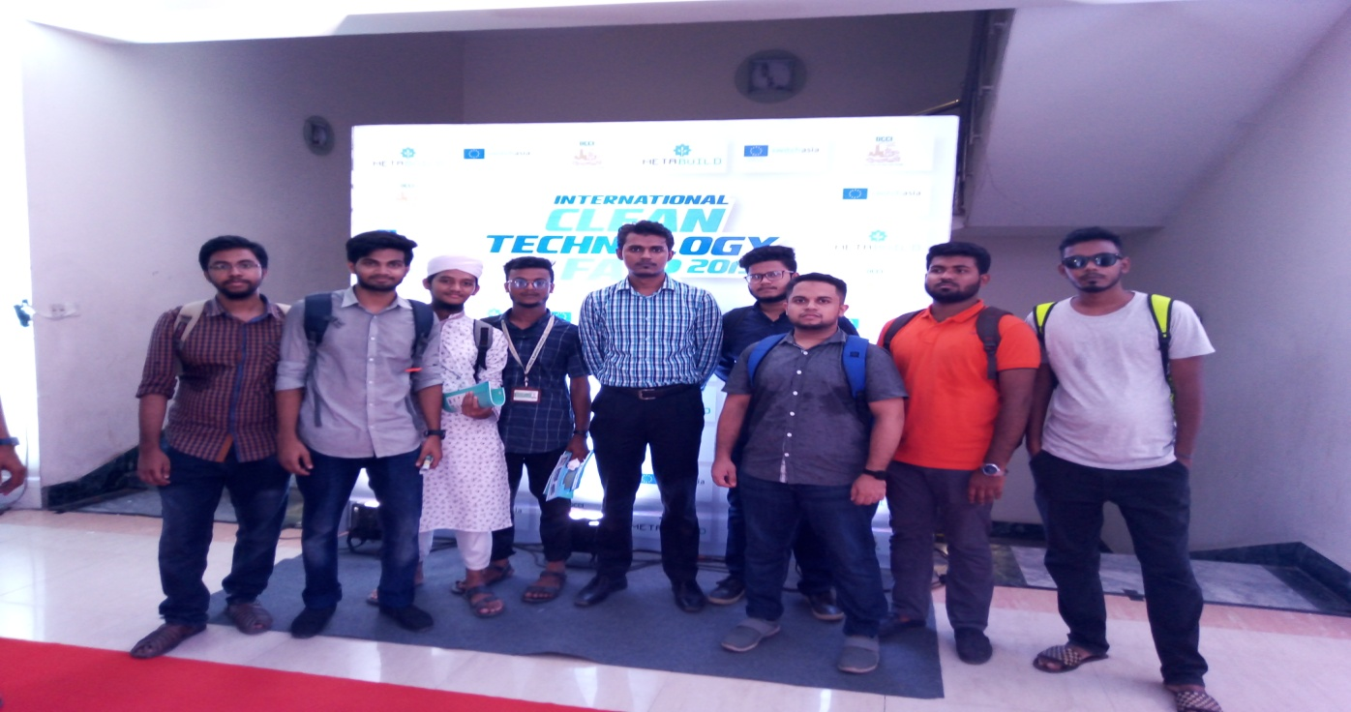
There were 74 stalls in the fair. The fair demonstrated the use of environment friendly machineries. Now a day’s different Industries are using technology that are not harmful for environment. International Clean Technology Fair, 2019 was a initiative to encourage that type of technology. Students earned practical knowledge about the machineries used in industries. Such kind of fair can enlighten the practical knowledge of the students along with their academic knowledge.
DBI College expects more and more initiative like this to enlighten the knowledge of Students.Students enjoyed a lot in the fair.

