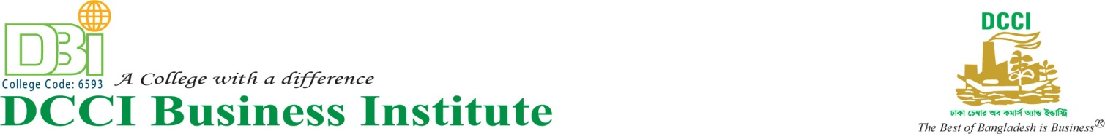

Date: June 25, 2019

Notice

All the students of 5th Batch 7th semester of BBA Program are informed that your formal Class will be started from July 09, 2019. You are asked to collect your class schedule.

The authority always expects your spontaneous cooperation for the betterment of you as well as of the Institute.

Khodeza Begum Academic
Principal Coordinator

